Static Code Analysis by Using Puma Scan
- Purpose of Performing Static Code Analysis:
Static code analysis is a useful method to check or examine source code, but not running the code. The purpose is to detect potential errors at an early stage, improve code quality, and enhance security standards. Performing static code analysis can save money, because fixing errors at a late stage during the project progress is generally costly. It can also improve code readability and maintainability and reduce the possibility of potential attacks.

- Method:
In this project, Puma Scan is used to do Static code analysis. Puma Scan community version is in use. It is installed as a Visual Studio extension. Once it is installed, it can scan all the source code and display the error list. Through the error list, we can go to check the error detailed information to understand thoroughly about the errors. Then a proper solution can be applied to address these errors to level up the security standards.

- Results Interpretation:
After doing static code analysis using Puma Scan, there were 39 warnings being found (Figure 3.1). These errors can be divided into five categories. They are SEC0120, SEC0019, SEC0115, CS8602, and CS8604. The table below shows the details of these vulnerabilities.

Vulnerabilities | What are they
SEC0120 | Missing Authorize Attribute (an access control issue)  It occurs when the application does not properly restrict access to only the authorized users.  This can lead to the high risk of unauthorized access to sensitive data.
SEC0019 | Missing Anti Forgery Token Attribute (a validation issue)  It means missing CSRF protection, which will make the application vulnerable to CSRF attack.  Cross-Site Request Forgery (CSRF) attack occurs when the user is using a trusted website, at the same time visits a malicious website unknowingly. Then the malicious website sends a fake request to the trusted website. The user’s valid authentication cookie from the trusted website is automatically included in the fake request, and the trusted website processes it and treats it as a valid but harmful action.
SEC0115 | Insecure Random Number Generator (insure cryptography issue)  It occurs when a program uses a cryptographically insure random number generator, such as the System.Random.
CS8602 | Dereference of a possibly null reference  It occurs when you try to access a variable, a method, or property which might be null. Thus, a NullReferenceException can be thrown and even the application can crash.
CS8604 | Possible null reference argument for parameter  It occurs when you assign a potentially null value to a non-nullable variable. This can lead to a runtime error.

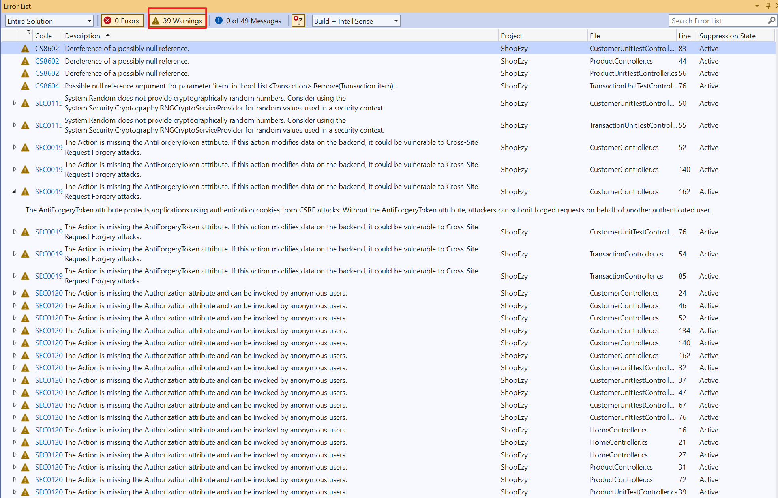
Figure 3.1 Screenshot of Error List

- Evaluation of these common security risks and vulnerabilities:
These risks and vulnerabilities identified by Puma Scan show the gaps between the source code and code safety. SEC0120 can lead to the exposure of sensitive information to unauthorized users. SEC0019 leaves the web application vulnerable to Cross-Site Request Forgery (CSRF) attacks, because of not checking user’s requests properly. SEC0115 occurs when there are predictable or cryptographically insure random number generators in the source code. This can leak sensitive data. Both CS8602 and CS8604 are all related to null reference. They can lead to crashes of the application. Fixing these vulnerabilities is crucial for the safety of sensitive data and the ensures the application’s overall stability.

- Possible solutions to fix SEC0120, SEC0019, and SEC0115:
The possible solutions to SEC0120, SEC0019, and SEC0115 come from Puma Scan rule documentation.

SEC0120:
Access control is managed in ASP.NET MVC, Web API, and .NET Core Controllers and Actions using the Authorize attribute. By using Authorize attribute in the source code, this issue can be fixed. This attribute can restrict the access right to only the authorized or authenticated users.
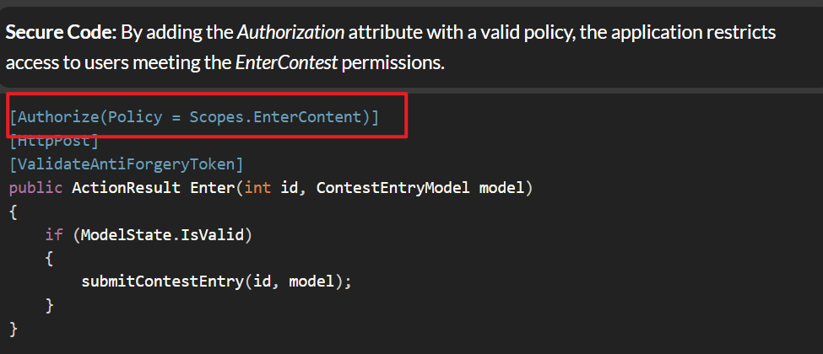
Figure 5.1 Screenshot of Solution to Addressing SEC0120

SEC0019:
To prevent CSRF attacks in ASP.NET MVC, ValidateAntiForgeryToken attribute can be used, as shown in Figure 5.2 below. This attribute can make sure that a valid __RequestVerificationToken will be contained in the request, then the application will check the request. This can ensure the request is from the user’s trusted website, not from a malicious one.
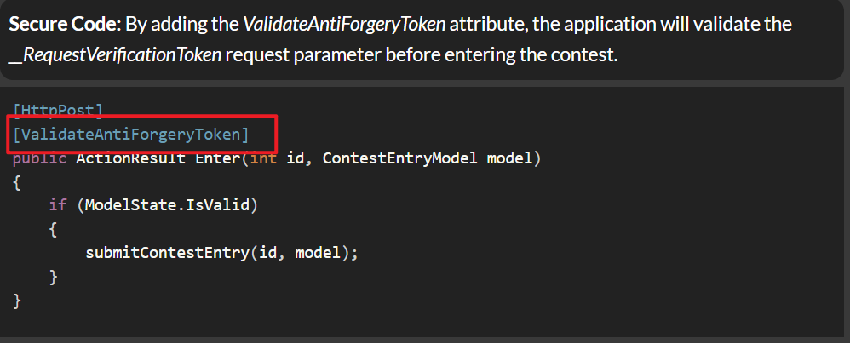
Figure 5.2 Screenshot of Solution to Addressing SEC0019

SEC0115:
Using System.Random to generate random values is not secure enough. Instead, if we want to generate random values securely in a security context, we can use system package like Security.Cryptography.RNGCryptoServiceProvider, as shown in Figure 5.3 below.

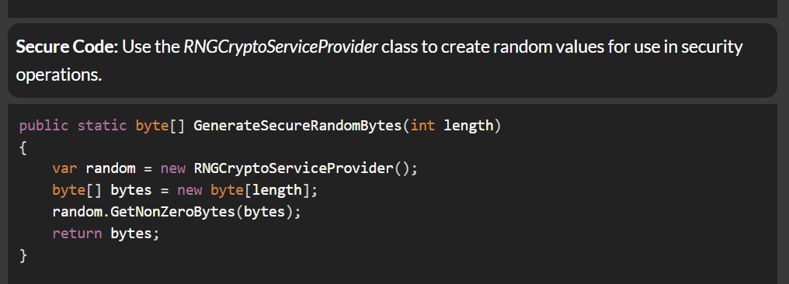
Figure 5.3 Screenshot of Solution to Addressing SEC0115

- Methods about addressing security flaws in the source code of ShopEasy Project:
Figures 6.1 and 6.2 show how we fix errors CS8602 and CS8604. The method we adopt is that checking a variable is not null before deferencing it. To ensure that before any update or operation is performed on an object, a valid customer object or transaction object is present in the list, thus preventing potential errors related to null references or invalid operations.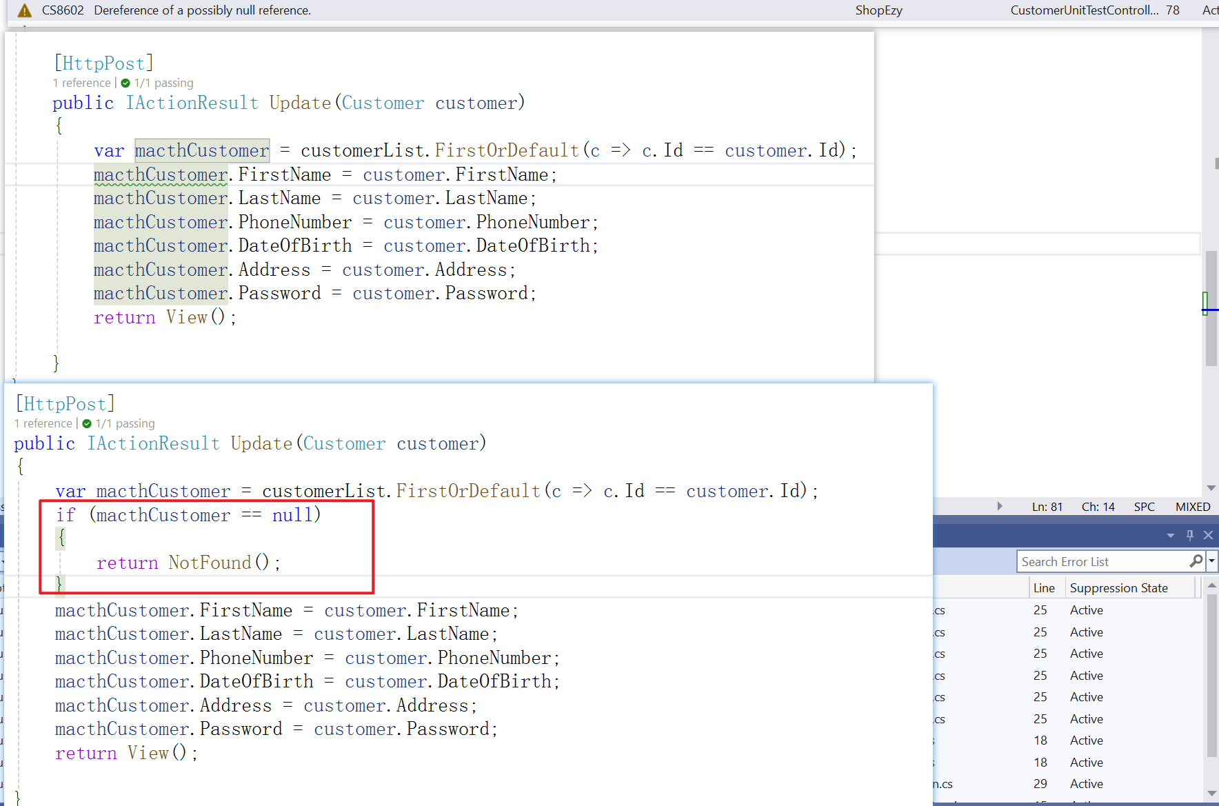
Figure 6.1 Screenshot of Solution to Addressing CS8602 in Source Code in ShopEasy Project
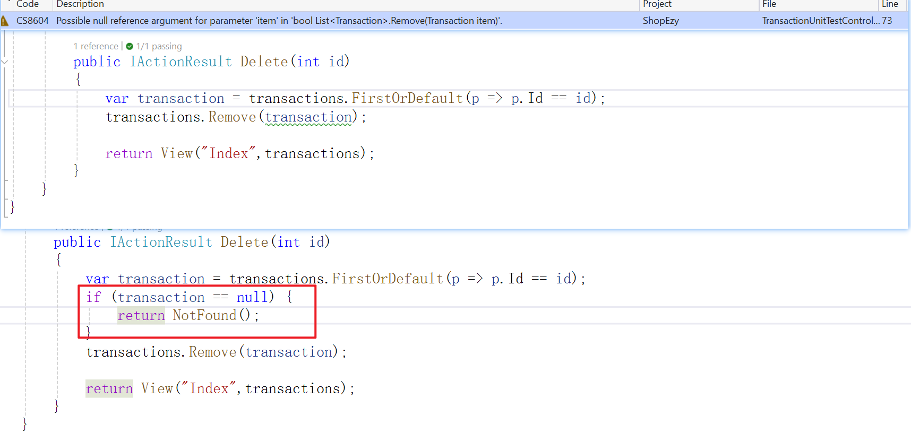
Figure 6.2 Screenshot of Solution to Addressing CS8604 in Source Code in ShopEasy Project

